
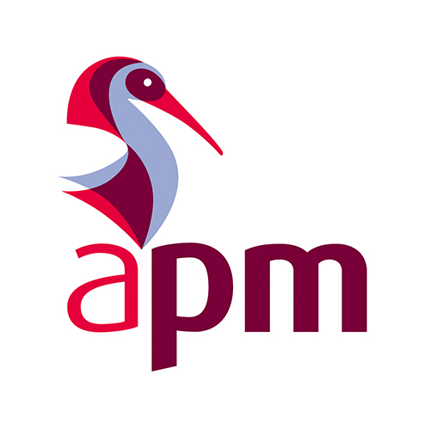

Continuing Professional Development and Record
Professional Development Plan (PDP) and Professional Development Record (PDR) for:
Philip Cook For the period 15/01/2020 to 31/06/2021
This report has three objectives
- To demonstrate that you have reflected on the ways in which you may need to develop your professional skills, knowledge and experience over the next 12 months to meet the needs of your role.
- To outline a plan of specific actions that you intend to take to meet these development objectives.
- To demonstrate that you have evaluated the learning outcomes achieved through completing these actions.
Development Objective | Start Date | Target Date | Development Outcome | Planned CPD Actions | Description of the Activity | Learning Outcome | Impact at Work
Describe the specific skill or competence that you intend to improve or develop. | When do you intend to start addressing this objective? | When do you intend to complete or review progress in achieving this objective? | Describe how you expect that achieving this objective will improve your performance. | Describe the specific activities you intend to undertake in order to meet this objective. | Describe the event, structured learning, informal learning, volunteering or other activity you undertook. | What have you learnt through completing this activity? How have your skills and knowledge improved or developed? | How has this learning made a difference to your capability and performance in your role?
Presentation skills | 10/03/2020 | 01/07/2020 | I expect that improving my presentation skills, something fundamental to PMs, I will be more effective in the role. | First task is to get past the first presentation, the assignment. I will work hard to accomplish this effectively. After this, I will work with my manager to acquire the possibility to present at work. | Presentation to group. Learning from reading journals and books on presentation, watching you tube tips and videos, reading online, reviewing my own recording and critically analysing it for improivement.
Confidence and Soft Skills | 01/01/2020 | 01/06/2020 | Gain confidence in both my own abilities, and in social environments; also work on soft skills in tandem. | Speak up at meetings, suggest ideas, and don’t be a dormouse. Reading (Building self-confidence with encouraging words, Wright 2009) and learning around confidence. Try and get a role managing a project to enable my skills to develop in people management. | Speaking out will show that there’s nothing to be scared of; everyone has opinions, and it’s not that scary. General day-to-day university will force me into groups of people that I am particularly worried about, again this should prove to be fine. I also wish to attend an APM networking event in order to aid this.
Patience with Creatives | 02/03/2020 | 16/03/2020 | Gain further understanding on the creative process to afford some patience towards these creatives. | A new bid arrived the date stated, this needs work with the “creatives”; therefore it is the perfect opportunity to get hands-on and understand what they do. | I will work alongside the individuals, ensuring I understand the processes that they go through. I have tom see the “chaos” as it is.
See the big picture | 02/03/2020 | 16/03/2020 | Try and understand the big picture, rather than getting stuck with the data analysis and the technical details | I will work with my manager to try and take a greater oversight of the new bid; while also doing my analytical part alongside. | Attend the executive meetings and ensure that I see their perspective. Understand the customers’ requirements in detail, speak with eh customer during the visit. Work on the softer, less analytical details on bid proposal.
Gain professional qualification and PM skills. | 01/01/2020 | 31/06/2021 (PMQ) & Lifetime | Gain my APM PMQ qualification, the first step in professional accreditation. This will make me somewhat competent. This learning will continue forever to make me an excellent PM. | Work hard to learn the material, understand the APM standards and ensure they are acquired and achieved, and pass the exams, achieve the degree, and progress as an individual. | This is a longer-term goal that will require a great deal of effort and learning, through many different mediums. Along with practical implication of the skills in my workplace.

